

AYEWO ATUNṢE Oil & Gas Services Ltd
28 Sikiru Oloko Alade Street, Off Adebayo Doherty, Lagos, NIGERIA
RC 9477114 — TIN 2622459761515

Technical & Commercial Proposal for

⟨ INSERT CLIENT LOGO HERE ⟩

PROJECT: | ⟨ Project description ⟩
CLIENT REFERENCE: | ⟨ Client PO / RFQ reference ⟩
DOCUMENT REF. NR. | AA-XXXX-INS-COM-01
AYEWO PROJECT REF NR. | AA XXXX — ⟨ Client ⟩: ⟨ Scope ⟩

This is a Project Controlled Document.

Rev | Date | Comments | Prepared By | Approved
00 | DD-MMM-YYYY | Issue for Submission | BLS

Contents

01 SCOPE OF WORK
02 EXECUTION METHODOLOGY
03 EQUIPMENT & CERTIFICATIONS
04 SCHEDULE AND MANPOWER
05 QUALITY, HEALTH AND SAFETY MANAGEMENT
06 COMMERCIAL PROPOSAL
07 TERMS AND CONDITIONS

1. SCOPE OF WORK

⟨ CUSTOMIZE THIS SECTION FOR EACH PROJECT ⟩
1.1 Scope Summary
⟨ Describe the asset, location, and the inspection scope. Example: ⟩
The [ASSET NAME] located [LOCATION] requires [NDT inspection / lifting equipment inspection / rope access inspection] in support of [planned maintenance / regulatory compliance / life extension program].
- Non-Destructive Testing (NDT) — UT thickness mapping, MPI, DPI on ⟨XX⟩ locations.
- Rope Access inspection of ⟨external structures / splash zone / flare tower⟩.
- Lifting equipment thorough examination and certification — ⟨XX⟩ items.
- Comprehensive inspection report with findings, recommendations, and certification.
1.2 Exclusions
⟨ List exclusions — e.g. remedial repairs, scaffolding erection, NORM areas ⟩
1.3 Reference Documents & Standards
- ISO 17640 — UT testing of welds
- ISO 17638 — Magnetic particle testing of welds
- LOLER 1998 / LEEA Code of Practice — Lifting equipment
- IRATA International Code of Practice — Rope Access
- ⟨ Client specific standards ⟩

2. EXECUTION METHODOLOGY

2.1 NDT Inspection Services
All NDT inspections performed by qualified technicians certified to ISO 9712 / PCN / ASNT standards.
Advanced NDT Methods
- Volumetric inspection of welds and corrosion mapping. Provides real-time C-scan imaging for accurate defect sizing and characterization.Phased Array UT (PAUT):
- High-accuracy weld inspection per EN ISO 10863. Detects and sizes planar defects with superior sensitivity.Time-of-Flight Diffraction (TOFD):
- Surface and near-surface flaw detection on non-ferrous materials and heat exchanger tubes.Eddy Current Testing:
Traditional NDT Methods
- Grid-based thickness mapping (250 × 250 mm grid) for corrosion assessment. Calibrated UT equipment with certificates.Ultrasonic Thickness (UT):
- Surface-breaking defect detection on ferromagnetic materials. Wet fluorescent and dry powder techniques.Magnetic Particle Inspection (MPI):
- Surface-breaking defect detection on non-ferromagnetic materials.Dye Penetrant Inspection (DPI):
- Volumetric inspection using Ir-192 or Se-75 sources. Full radiation safety controls and zoning.Radiographic Testing (RT):
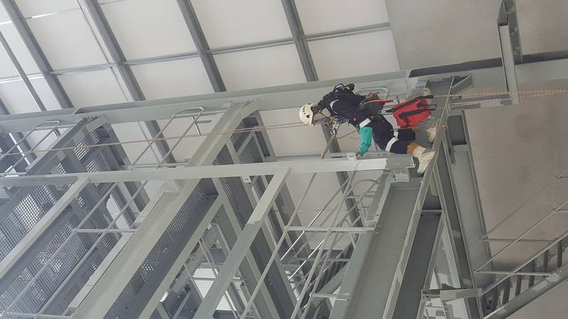
Figure 1: Rope Access Inspection Operations
2.2 Lifting Equipment Inspection
Thorough examination and certification of all categories of lifting equipment and accessories in accordance with LOLER 1998 and LEEA Code of Practice:
- Cranes (pedestal, deck, overhead, gantry, jib, mobile) — structural integrity, wire ropes, sheaves, hooks, brakes, limit switches, load indicators.
- Hoists & Winches — load chain, hooks, latches, brakes, limit devices.
- Lifting Beams & Spreader Bars — structural inspection, MPI of welds, dimensional verification.
- Loose Lifting Gear — shackles, slings (wire rope, chain, webbing), eyebolts, pad eyes, beam clamps.
- Colour coding, condemned equipment quarantine and disposal management.
- Complete lifting register maintenance and compliance tracking.
2.3 Rope Access Services
All rope access operations performed by IRATA-certified technicians (Level 1, 2, and 3). Rope access provides cost-effective alternative to scaffolding for inspection of structures including:
- Flare towers, derricks, and tall structures
- External hull and splash zone areas on FPSOs
- Under-deck and confined space inspection
- Combined rope access + NDT for difficult-to-reach weld inspections

3. EQUIPMENT & CERTIFICATIONS

3.1 NDT Equipment
Equipment | Method | Certification
Phased Array UT Flaw Detector | PAUT / TOFD | Calibrated
Conventional UT Thickness Gauge | UT | Calibrated
MPI Yoke (AC/DC) | MPI | Certified
UV Lamp (for fluorescent MPI) | MPI | Calibrated
DPI Kit (cleaner, penetrant, developer) | DPI | In-date materials
Radiography Source (Ir-192 / Se-75) | RT | Licensed & sealed
3.2 Personnel Certifications
Certification | Standard | Required For
NDT Level II / III | ISO 9712 / PCN / ASNT | All NDT technicians
IRATA Level 2 / 3 | IRATA ICOP | Rope access personnel
Lifting Inspector | LEEA Diploma | Lifting equipment inspection
BOSIET / HUET + OGUK Medical | OPITO | All offshore personnel

4. SCHEDULE AND MANPOWER

4.1 Execution Schedule
⟨ ADJUST PHASES AND DURATIONS PER PROJECT SCOPE ⟩
Phase | Activity | Duration | Days
1 | Mobilisation & Site Setup | X days | Day 1–X
2 | NDT Inspection Campaign | X days | Day X–X
3 | Lifting Equipment Inspection | X days | Day X–X
4 | Reporting & Demobilisation | X days | Day X–X
4.2 Team Composition
Function | Nat. | UoM | Loc. | Rate | Qty | Duration
NDT Level III Supervisor | Expat | Day | Offshore | $ XXX | 1 | XX
NDT Level II Technician | National | Day | Offshore | $ XXX | 2 | XX
Rope Access Technician (IRATA L2/L3) | National | Day | Offshore | $ XXX | 2 | XX
Lifting Inspector (LEEA) | National | Day | Offshore | $ XXX | 1 | XX
NDT Assistant | National | Day | Offshore | $ XXX | 1 | XX

QUALITY, HEALTH AND SAFETY MANAGEMENT

AYEWO ATUNṢE maintains an integrated QHSE Management System.
- Comprehensive risk assessment and Job Safety Analysis (JSA) for all activities.
- Daily toolbox talks and pre-task briefings.
- Compliance with client HSE requirements and work permit system.
- All personnel offshore-certified (BOSIET/HUET, OGUK Medical).
- All NDT equipment calibrated and certified.
- Radiation safety controls and exclusion zones for RT operations.
- IRATA safety management system for rope access.
Documentation Deliverables
- Method Statement & execution schedule
- Risk Assessment & JSA
- Daily progress reports
- NDT inspection reports with defect mapping
- Lifting equipment certificates and colour-coded register
- Final Inspection Report & Work Completion Certificate (WCC)

COMMERCIAL PROPOSAL

SOW: ⟨ Repeat scope summary ⟩
⟨ FILL IN ALL RATES, QUANTITIES AND DURATIONS ⟩
Personnel Rates
Function | Nat. | UoM | Loc. | Rate | Qty | Duration | Total
NDT Level III Supervisor | Expat | Day | Offshore | $ XXX | 1 | XX | $ XX,XXX
NDT Level II Technician | National | Day | Offshore | $ XXX | 2 | XX | $ XX,XXX
Rope Access Tech (IRATA) | National | Day | Offshore | $ XXX | 2 | XX | $ XX,XXX
Lifting Inspector | National | Day | Offshore | $ XXX | 1 | XX | $ XX,XXX
NDT Assistant | National | Day | Offshore | $ XXX | 1 | XX | $ X,XXX
Personnel Rates Subtotal: |  |  |  |  |  |  | $ XXX,XXX.XX

Set-Up, Mobilisation & Accommodation Rates
Description | UoM | Rate | Qty | Duration | Total
Mobilisation Subtotal: |  |  |  |  | $ XX,XXX.XX

Equipment Rates
Description | UoM | Rate | Duration | Total
Phased Array UT Flaw Detector
Conventional UT Gauge
MPI Yoke + UV Lamp
DPI Kit
Rope Access Kit (full set)
Radiography Source + Controls
Equipment Rates Subtotal: |  |  |  | $ XX,XXX.XX

Personnel Rates: | $ XXX,XXX.XX
Mobilisation & Accommodation: | $ XX,XXX.XX
Equipment Rates: | $ XX,XXX.XX
Consumable Rates: | $ XXX,XXX.XX
TOTAL: | $ XXX,XXX.XX

TERMS AND CONDITIONS

– This quote is subject to our Standard Terms & Conditions available on request.
– Duration is estimated and indicative; billing based on actual worked time.
– Personnel and Equipment rates begin on mobilisation day, end on return to origin.
– Final payment after sign-off of Work Completion Certificate (WCC) or Delivery Note.
– Cost variations after expiry will be justified and passed onto the price.
– Excludes all applicable taxes.
– Material lead time — 2 Weeks.
– Manpower lead time — 3 Weeks.
– Offer validity — 30 days from date of submission.

Thank you for this opportunity.

Yours sincerely,

Name: ________________________________
Title: INS Department

