

AYEWO ATUNṢE Oil & Gas Services Ltd
28 Sikiru Oloko Alade Street, Off Adebayo Doherty, Lagos, NIGERIA
RC 9477114 — TIN 2622459761515

Technical & Commercial Proposal for

⟨ INSERT CLIENT LOGO HERE ⟩

PROJECT: | ⟨ Project description ⟩
CLIENT REFERENCE: | ⟨ Client PO / RFQ reference ⟩
DOCUMENT REF. NR. | AA-XXXX-AIS-COM-01
AYEWO PROJECT REF NR. | AA XXXX — ⟨ Client ⟩: ⟨ Scope summary ⟩

This is a Project Controlled Document and should be retained by an authorized person only.
If this document was not specifically issued to its user, then the user must obtain a controlled copy from the Project Manager.

Rev | Date | Comments | Prepared By | Approved
00 | DD-MMM-YYYY | Issue for Submission | BLS

Contents

01 SCOPE OF WORK
02 EXECUTION METHODOLOGY
03 MATERIAL REQUIREMENTS
04 SCHEDULE AND MANPOWER
05 QUALITY, HEALTH AND SAFETY MANAGEMENT
06 COMMERCIAL PROPOSAL
07 TERMS AND CONDITIONS

1. SCOPE OF WORK

⟨ CUSTOMIZE THIS SECTION FOR EACH PROJECT ⟩
1.1 Scope Summary
⟨ Describe the asset, location, and the defect requiring repair. Example: ⟩
The [ASSET NAME] located [LOCATION] requires composite repair due to [extensive corrosion / wall thinning / leak] identified during routine inspection. The objective is to restore structural integrity using Technowrap™ 2K composite wrapping technology, in support of the asset's life extension program.
- Cleaning and surface preparation of all corroded areas using UHP water jetting and mechanical preparation.
- UTM (Ultrasonic Thickness Measurement) gauging on a 250 × 250 mm grid to assess remaining plate thickness.
- Composite Technowrap™ 2K wrapping repair of approximately ⟨XX⟩ m² of affected area (⟨X⟩ layers of 2K cloth) per design calculation ⟨WTR-XXXXX⟩.
- Waste collection, containment and removal of all debris.
1.2 Exclusions
EXCLUSION — HYDROTEST
This proposal does not include hydrostatic testing. Hydrostatic testing is performed by the client's offshore maintenance crews upon completion and acceptance of all composite repair works.
EXCLUSION — NORM
This quotation assumes no Naturally Occurring Radioactive Material (NORM) is present. Should NORM be identified, the scope, methodology, and cost will require significant revision.
1.3 Access Requirements
⟨ Describe access method — scaffolding, rope access, etc. Specify who provides it. ⟩
1.4 Reference Documents
- ⟨ WTR-XXXXX ⟩ — AYEWO ATUNṢE / ICR Integrity — Composite Repair Design Calculation
- ⟨ Client reference ⟩ — Construction / Location drawings
- ⟨ Inspection report reference ⟩ — UTM inspection data
- ICR-BMS-01-OPS-PRO-004 — Technowrap™ Master Installation Procedure

2. EXECUTION METHODOLOGY

All composite repairs are executed in strict accordance with the ICR Integrity Technowrap™ Master Installation Procedure (ICR-BMS-01-OPS-PRO-004). The methodology below describes the standard execution phases.
2.1 Phase 1 — Mobilisation & Site Setup
- Mobilise all personnel and equipment to the asset via ⟨logistics method⟩.
- Attend client HSE induction and obtain work permits.
- Set up UHP water jetting equipment (40,000 PSI), MBX Bristle Blasters, blast pot, and composite repair materials in designated staging area.
- Coordinate with client for scaffolding configuration, ventilation, and utilities (water, air, power).
2.2 Phase 2 — Cleaning, Surface Preparation & Inspection
UHP Water Jetting
The primary cleaning method is Ultra-High Pressure (UHP) water jetting at 40,000 PSI, operated by a certified UHP Technician (Expat) supported by Skilled UHP Operators (National). The UHP system removes all loose and adherent corrosion products, scale, and marine growth from internal/external surfaces.
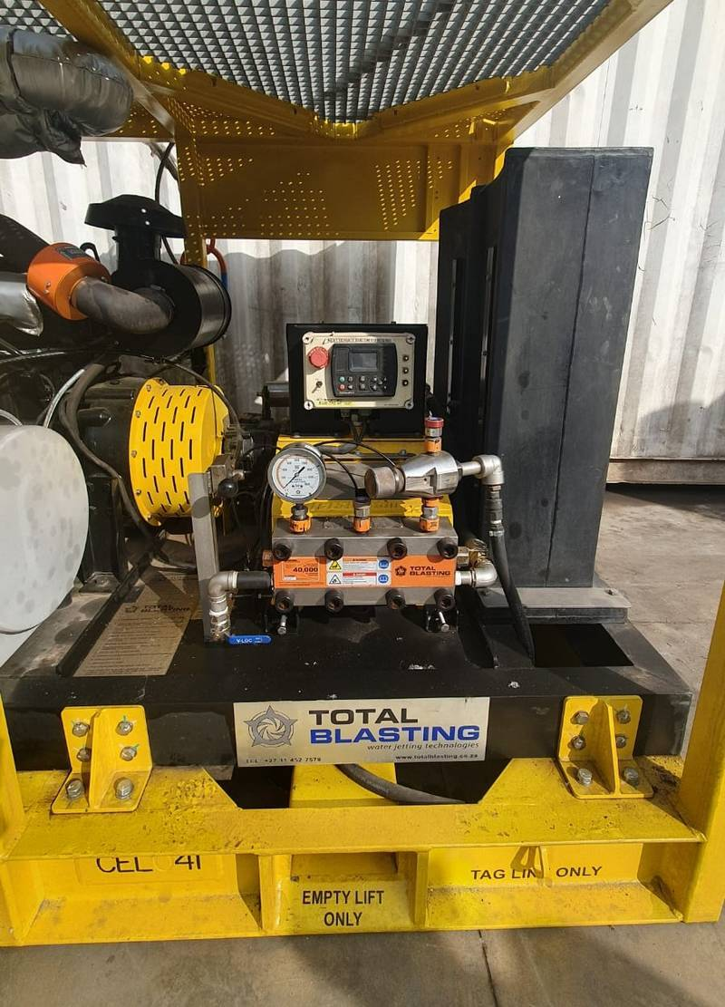
Figure 1: UHP Water Jetting Equipment
Mechanical Surface Preparation
Surfaces designated for composite application undergo mechanical preparation using MBX Bristle Blasters and/or abrasive blasting:
- Near-white metal, surface profile ≥65 μm.Sa 2.5 (Abrasive Blasting):
- Bristle Blaster preparation, surface profile ≥40 μm on restricted areas.ST3 (Mechanical):
Surface preparation extends 25 mm beyond the repair area to ensure the composite lands on prepared substrate. All profile measurements are taken using Testex X-Coarse replica tape and recorded for the close-out report.
UTM Inspection
Ultrasonic Thickness Measurement performed by a certified NDT Inspector on a 250 × 250 mm grid across all cleaned surfaces. Comprehensive inspection report with updated corrosion map issued for client approval prior to composite repair.

2.3 Phase 3 — Composite Repair Application
Technowrap™ 2K — Technology
Technowrap™ is an advanced cold-work composite repair system by ICR Integrity. E-glass fibrous reinforcements impregnated with a two-part epoxy resin. Fully qualified to ISO 24817:2017, ASME PCC-2 Article 4.1, with ABS Product Design Assessment approval. Temperature range: -75°C to 220°C. Pressure: up to 1,400 BarG. Design life: up to 20 years.
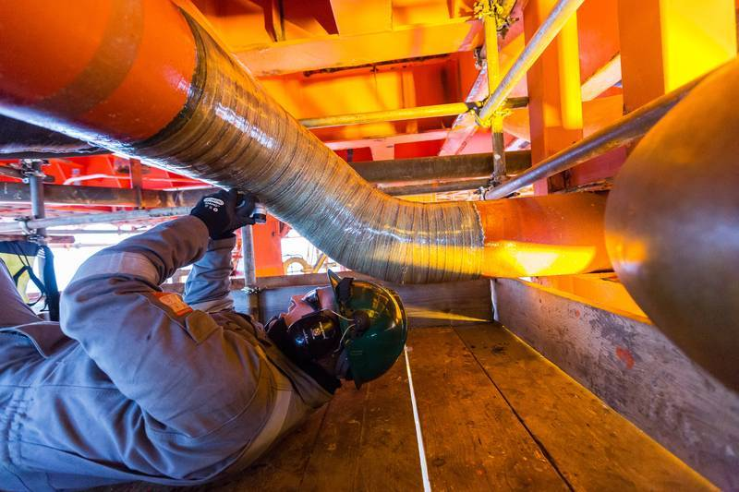
Figure 2: Technowrap™ Composite Repair Application
Application Methodology
The following steps are performed in strict accordance with ICR-BMS-01-OPS-PRO-004:
1. Surface Verification: Confirm cleanliness (Sa 2.5 / ST3), profile standards (≥65 μm blast / ≥40 μm mechanical), humidity <85%, substrate ≥3°C above dew point.
2. 3K Primer Application: Apply Technowrap 3K primer (Silane + Methanol + Fresh Water, ratio 1:20:100) to prepared substrate. Primer must stand 1 hour before use, then be painted onto surface and left 30 minutes for chemical reaction. Dried with hot air blower.
3. Gel Coat: Mix Technowrap Resin Part A and Part B per measurement chart. Apply thorough coating of gel coat over prepared surface within 4 hours of surface preparation. Failure to meet the 4-hour window requires re-preparation of the substrate.
4. Profiling: All flanges, nozzles, sharp corners, dents, and wall offsets >3 mm smoothed with Technowrap profiling compound (Technoseal Epoxy Putty, Titanium Putty, or similar). Profiling compound treated as a defect — if larger than design calculation, ICR notified for redesign.
5. Substrate & Cloth Lay-up: Apply Technowrap 2K Substrate (12") as bonding layer. Pour mixed resin onto cloth, spread evenly with spreader, work in with corrugated roller. Apply +45 side down, 90° fibres around circumference. Each layer offset by ≥75 mm (brickwork pattern). First 2 layers applied onto wet gel coat.
6. Compression: After every 2–3 layers, compress repair using stricture tape — start from centre, spiral to one edge with 50% overlap, then centre to other edge. Forces air pockets and resin-rich areas out. Peel ply applied between compression cycles to provide keyed surface for next layers.
7. Inter-layer Curing: Each group of layers cured until dry to touch, does not indent when pressed with fingernail. QC inspection between each application cycle.
8. Final Cure Verification: Barcol Hardness testing at 16 locations (minimum target: 35 across all points). Confirms full structural properties achieved. Cure time dependent on resin system and ambient temperature — see cure schedule.

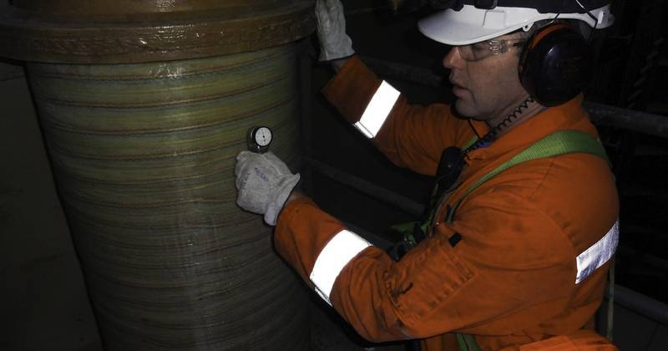
Figure 3: Completed Composite Repair — Inspection & QC
Resin Cure Schedule (Reference)
Cure times are indicative and depend on ambient temperature, humidity, and substrate temperature. Barcol hardness readings confirm final cure.
Temp (°C) | Pot Life (min) | Partial Cure (hrs) | Full Cure (hrs)
45 | 4 | 0.25 | 6
35 | 8 | 0.5 | 12
25 | 15 | 0.75 | 24
15 | 30 | 1 | 48
5 | 60 | 3 | 96
Table: LT & Potable Resin cure schedule. For HA, HT, DRS, Splashzone and Glycol resins, refer to ICR-BMS-01-OPS-PRO-004.
2.4 Phase 4 — Additional Repairs
⟨ If nozzle repairs or additional areas: Same Technowrap™ 2K methodology, but with layer count per specific WTR design calculation for each geometry. ⟩
2.5 Phase 5 — Documentation & Demobilisation
- Final as-built documentation: application records, QC records, Barcol test results, material certificates, updated corrosion maps.
- Hand over Work Completion Certificate (WCC) and close-out report.
- Demobilise all personnel and equipment.

3. MATERIAL REQUIREMENTS

All composite materials sourced through ICR Integrity, certified for offshore structural repair. Quantities calculated per identified repair areas and applicable design specifications.
3.1 ICR Materials — ⟨ Area Description ⟩
⟨ CUSTOMIZE QUANTITIES PER WTR DESIGN CALCULATION ⟩
Material | Unit | Rate | Qty | Total (USD)
Technowrap 2K Substrate — 12" | Kg | $ XXX.XX | XXX | $ XX,XXX.XX
Technowrap LT Resin Part A | Kg | $ XXX.XX | XXX | $ XX,XXX.XX
Technowrap HA Resin Part B | Kg | $ X,XXX.XX | XX | $ XX,XXX.XX
Consumables for wrapping application | Ea | $ XX,XXX.XX | 1 | $ XX,XXX.XX
3.2 Surface Preparation Consumables
Material | Unit | Rate | Qty | Total (USD)
Blasting Abrasive | Kg | $ X.XX | X,XXX | $ XX,XXX.XX
MBX Bristle Blasters (23mm CS) | Each | $ XXX.XX | XX | $ X,XXX.XX
Material lead time: 2 weeks from order confirmation. Manpower lead time: 3 weeks from contract award.

4. SCHEDULE AND MANPOWER

4.1 Execution Schedule (⟨XX⟩ working days)
⟨ ADJUST PHASES AND DURATIONS PER PROJECT SCOPE ⟩
Phase | Activity | Duration | Days
1 | Mobilisation & Site Setup | X days | Day 1–X
2 | Cleaning, Surface Prep & UTM Inspection | X days | Day X–X
3 | Composite Repair — ⟨Area 1⟩ | X days | Day X–X
4 | Composite Repair — ⟨Area 2⟩ | X days | Day X–X
5 | Documentation & Demobilisation | X days | Day X–X
4.2 Team Composition (⟨X⟩ PAX)
A qualified and experienced team will be mobilised to execute all operations in compliance with applicable legislation and offshore safety requirements.
Function | Nat. | UoM | Loc. | Rate | Qty | Duration
Supervisor — Composite Repair Applicator | Expat | Day | Offshore | $ XXX | X | XX
Skilled — Composite Repair Applicator | National | Day | Offshore | $ XXX | X | XX
UHP Technician | Expat | Day | Offshore | $ XXX | X | XX
Skilled — UHP Operator | National | Day | Offshore | $ XXX | X | XX
Multi-Discipline NDT Inspector | Expat | Day | Offshore | $ XXX | X | X
Skilled — NDT Assistant | National | Day | Offshore | $ XXX | X | X

5. QUALITY, HEALTH AND SAFETY MANAGEMENT

AYEWO ATUNṢE maintains an integrated QHSE Management System. All composite works are performed per ABS classification requirements and ICR application procedures.
- Comprehensive risk assessment and Job Safety Analysis (JSA) for all activities.
- Daily toolbox talks and pre-task briefings.
- Compliance with client HSE requirements and work permit system.
- All personnel offshore-certified (BOSIET/HUET, OGUK Medical).
- All composite works per ABS classification requirements and ICR application procedures.
Documentation Deliverables
- Method Statement & execution schedule
- Risk Assessment & JSA
- Daily progress reports
- UTM inspection report with corrosion mapping
- Composite repair application records (per area)
- Material certificates with batch traceability
- Barcol Hardness test records (16-point grid)
- Final Work Completion Certificate (WCC)

6. COMMERCIAL PROPOSAL

SOW: ⟨ Repeat scope summary — one line ⟩
⟨ FILL IN ALL RATES, QUANTITIES AND DURATIONS ⟩
Personnel Rates
Function | Nat. | UoM | Loc. | Rate | Qty | Duration | Total
Personnel Rates Subtotal: |  |  |  |  |  |  | $ XXX,XXX.XX

Set-Up, Mobilisation & Accommodation Rates
Description | UoM | Rate | Qty | Duration | Total
Mobilisation & Accommodation Rates Subtotal: |  |  |  |  | $ XX,XXX.XX

Equipment Rates
Description | UoM | Rate | Duration | Total
QC Inspection Kit for Technowrap
Pneumatic MBX Bristle Blaster
Blast Pot
1" Airhose (20m)
UHP Machine 40k
Equipment Rates Subtotal: |  |  |  | $ XX,XXX.XX

Consumable Rates
Description | UoM | Rate | Qty | Total
Blasting Abrasive
MBX Bristle Blasters (23mm CS)
ICR — Technowrap 2K Substrate — 12"
ICR — Technowrap LT Resin Part A
ICR — Technowrap HA Resin Part B
ICR — Consumables for wrapping application
Consumable Rates Subtotal: |  |  |  | $ XXX,XXX.XX

Personnel Rates: | $ XXX,XXX.XX
Set-Up, Mobilisation & Accommodation Rates: | $ XX,XXX.XX
Equipment Rates: | $ XX,XXX.XX
Consumable Rates: | $ XXX,XXX.XX
TOTAL: | $ XXX,XXX.XX

7. TERMS AND CONDITIONS

– This quote is subject to our Standard Terms & Conditions available on request.
– Duration is estimated and indicative; billing based on actual worked time.
– Personnel and Equipment rates begin on mobilisation day, end on return to origin.
– Final payment after sign-off of Work Completion Certificate (WCC) or Delivery Note.
– Cost variations after expiry will be justified and passed onto the price.
– Excludes all applicable taxes.
– Material lead time — 2 Weeks.
– Manpower lead time — 3 Weeks.
– Offer validity — 30 days from date of submission.

Thank you for this opportunity.

Yours sincerely,

Name: ________________________________
Title: AIS Department

